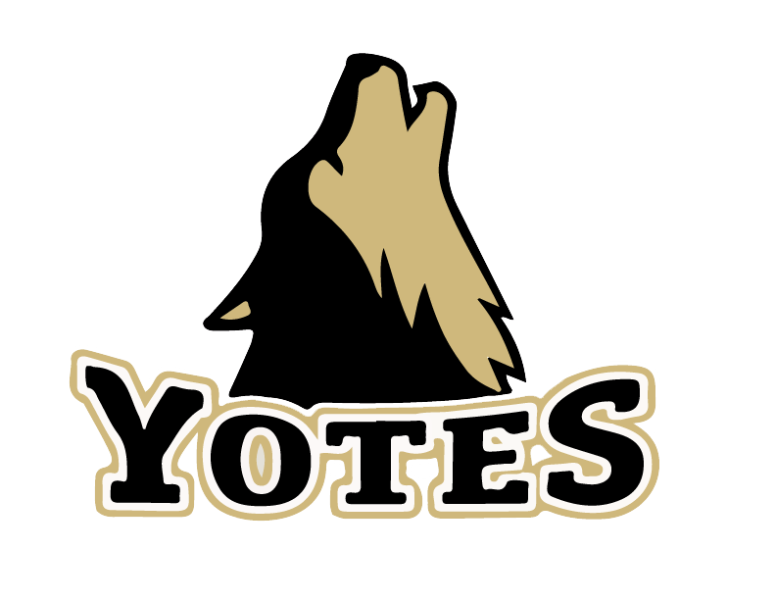
Top of the Rockies
Youth Basketball Camp
__________________________________
June 8th–10th, 2015
@ Monarch High School
9:00am – 12:00pm
Grades 3rd – 8th
$80 Registration Fee

Camp Description: The Top of The Rockies Youth Camp is designed to introduce new skills to youth basketball players. The camp will use age appropriate activities and games to give opportunities to learn fundamentals of basketball. The fundamentals the campers learn will lay a foundation for their future in more then just basketball.

For more information visit: mohibasketball.weebly.com

Name:______________________________________ Grade next year:_____

I understand the dangers of participation in sports and I agree to release the directors of
Monarch coaching staff, as well as Monarch high school from any injuries that may occur. I also
give my permission for my child to be treated by the proper medical authorities if a medical
emergency takes place.

Parent/Guardian Name: ______________________________________________________

Signature___________________________________________________________________Date______________

Emergency Contact: ______________________________Phone: ___________________________________

